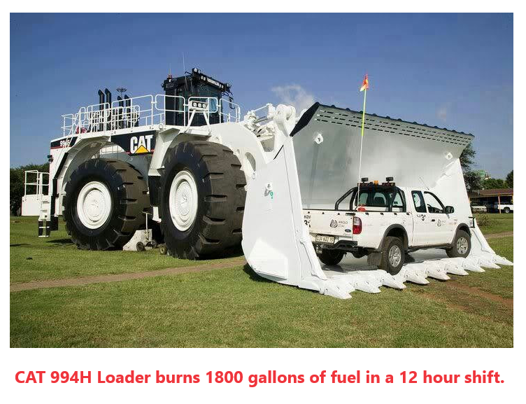
“A machine like this is required to move 500 tons of earth/ore which will be refined into one lithium car battery.

Lithium is refined from ore using sulfuric acid. The proposed lithium mine at Thacker Pass, Nevada is estimated to require up to 75 semi-loads of sulfuric acid a day!
The acid does not turn into unicorn food as AOC believes.

Refining lithium has created several EPA SUPERFUND SITES.

IT IS VERY TOXIC TO THE ENVIRONMENT!

A battery in an electric car, let’s say an average Tesla, is made of:

25 pounds of lithium, 60 pounds of nickel, 44 pounds of manganese, 30 pounds of cobalt, 200 pounds of copper, and 400 pounds of aluminum, steel, and plastic, etc.... averaging 750- 1,000 pounds of minerals, that had to be mined and processed into a battery that merely stores electricity.... Electricity which is generated by oil, gas, coal, or water ( and a tiny fraction of wind and solar )

That is the truth, about the lie of "green" energy.

There’s nothing green about the "Green New Deal".

You people better learn how to vote, or this nonsense will continue to flow down on top of you from the throne of government upon of which you put these people.

Stop drinking the Green New Deal’s sulfuric acid Kool-Aid!

Dr. Phillip A. Fields
University of South Alabama
Mobile, Alabama

